# Byron Laferriere

Professor Gupta

DAD-220

31 May 2020

# DAD 220 Cardinality and Targeted Data Template

1. **Retrieve employee tuples** and **identify the number of employees in San Francisco and New York.**

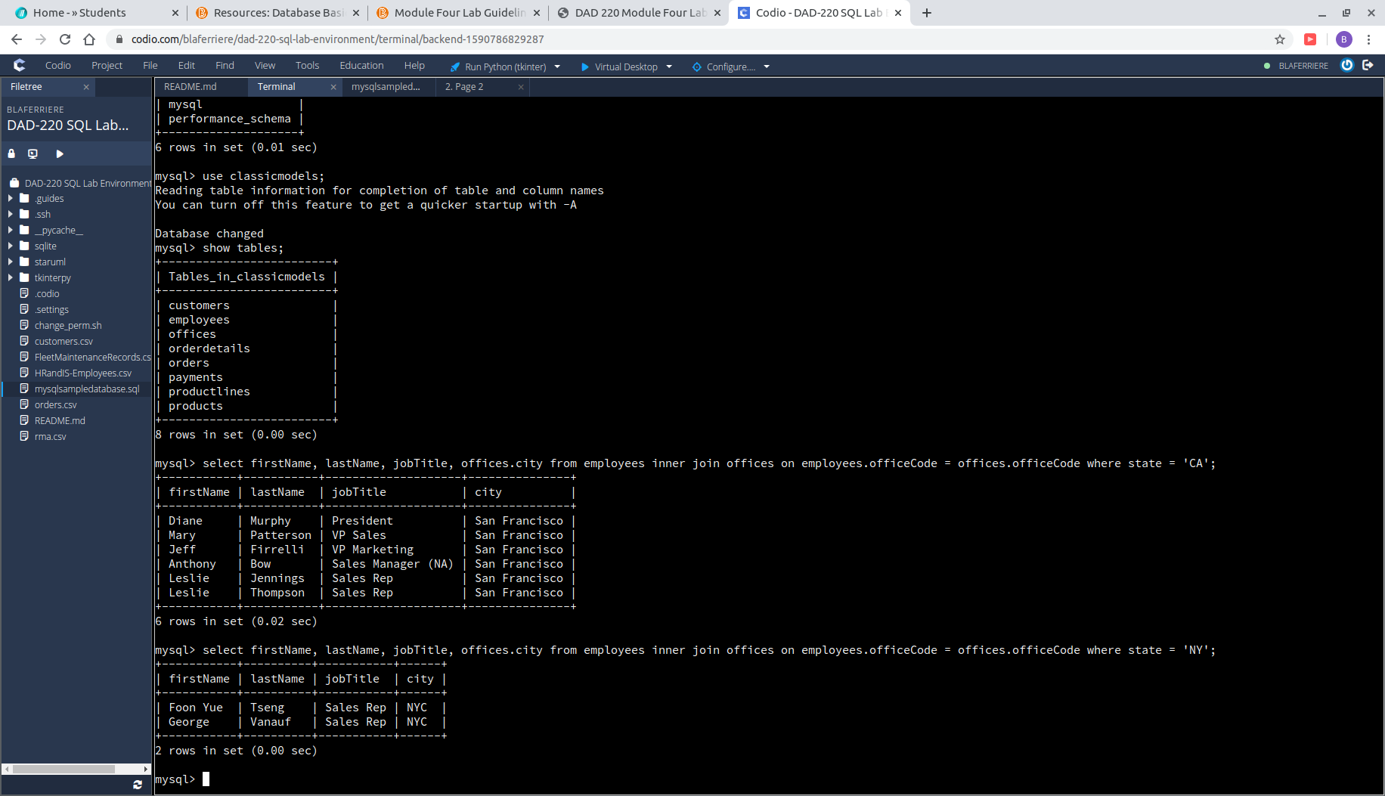

1. **Retrieve order details** for orderNumber 10330, 10338, and 10194 and **identify what type of cardinality this represents in the entity relationship model.**

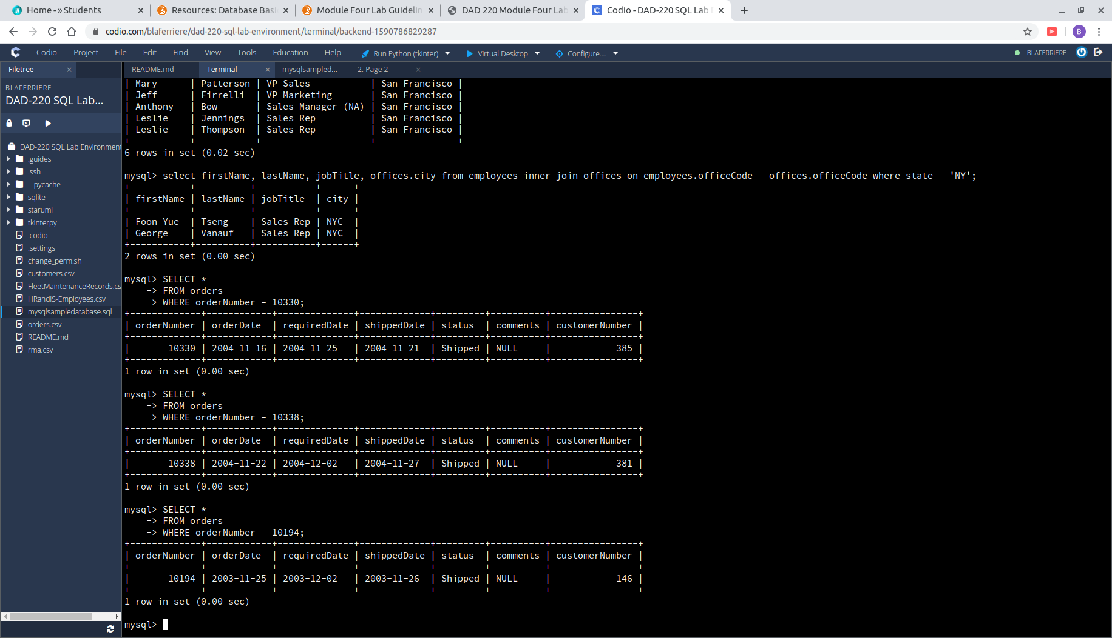

* 1. The cardinality that is highlighted in this example is a one-one maxima. Per one orderNumber there is one customer placing each.

1. **Delete records** from the payments table where the customer number equals 103.

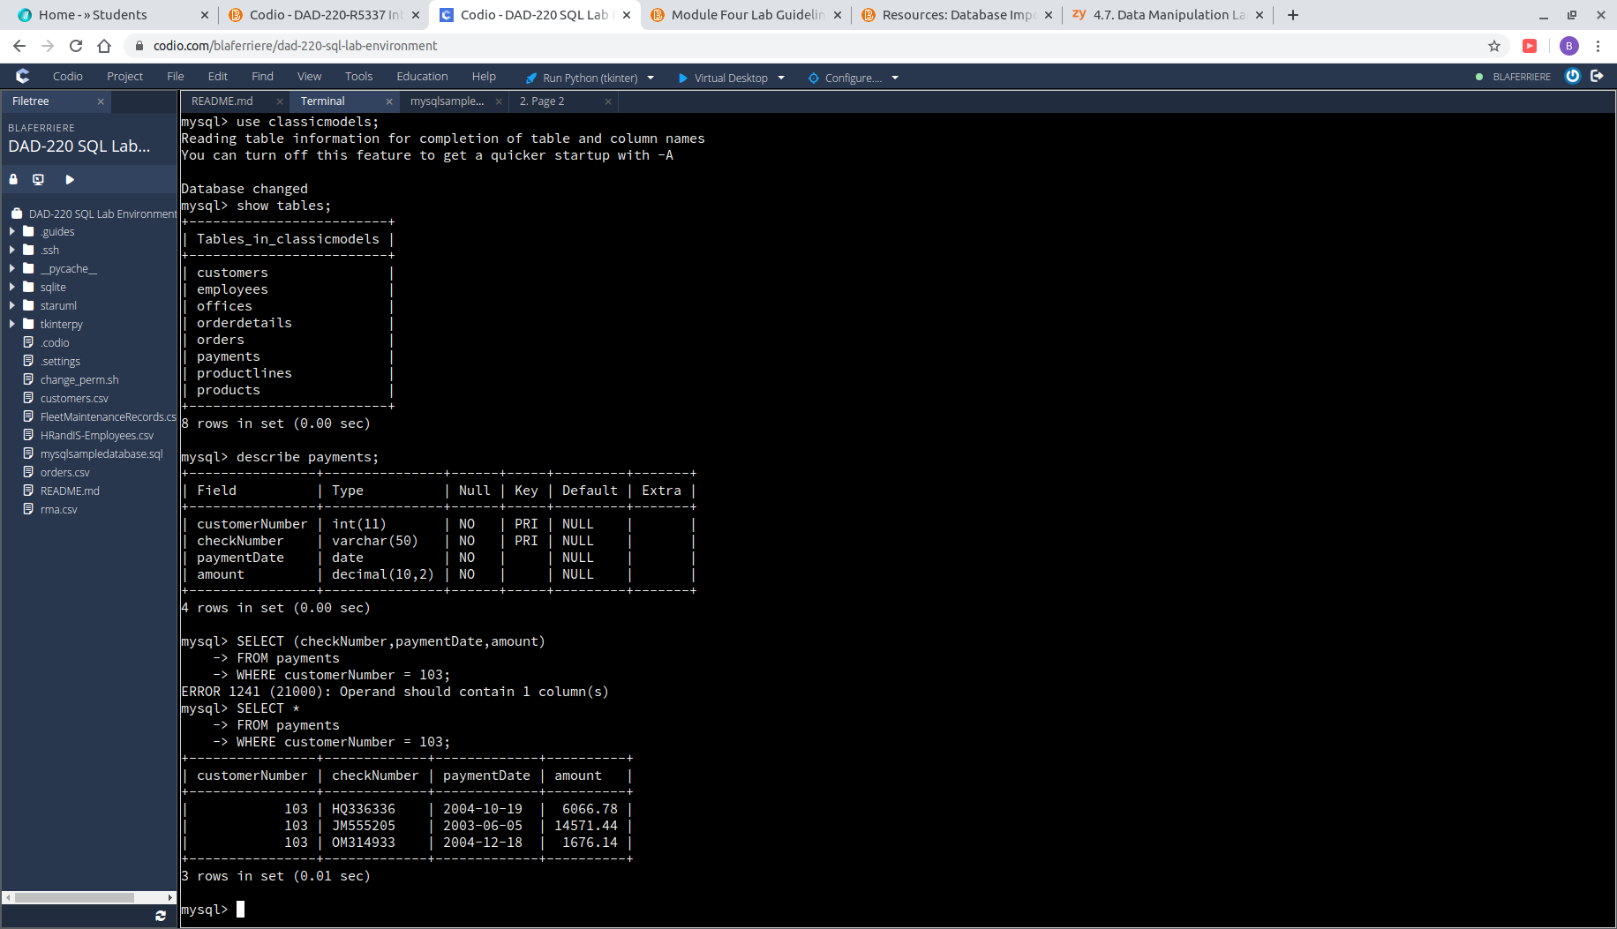

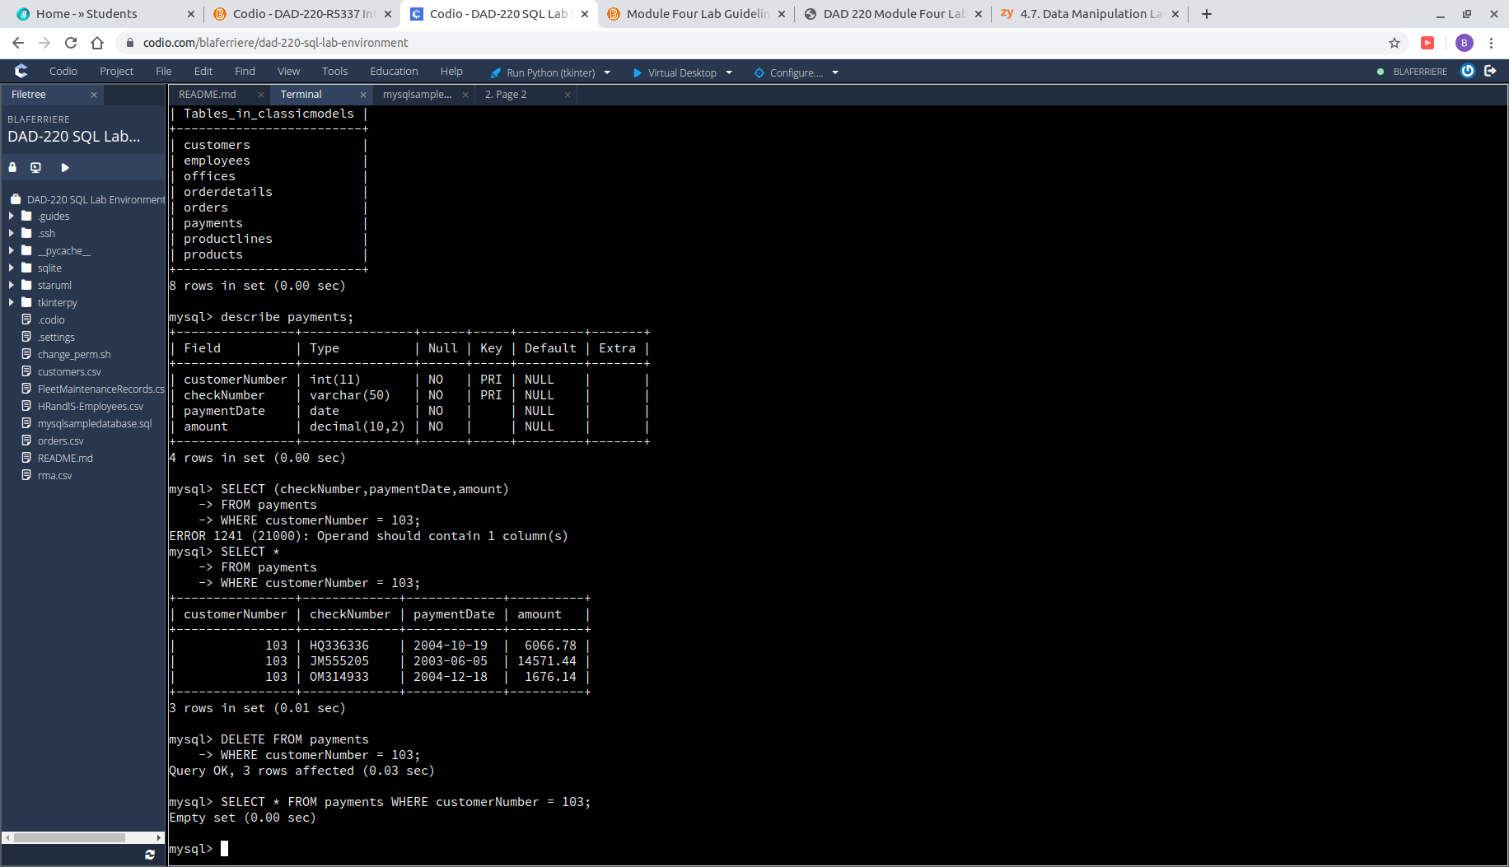

1. **Retrieve customer records** for employee Rep Barry Jones and **identify** if the relationships are one-to-one or one-to-many**.**

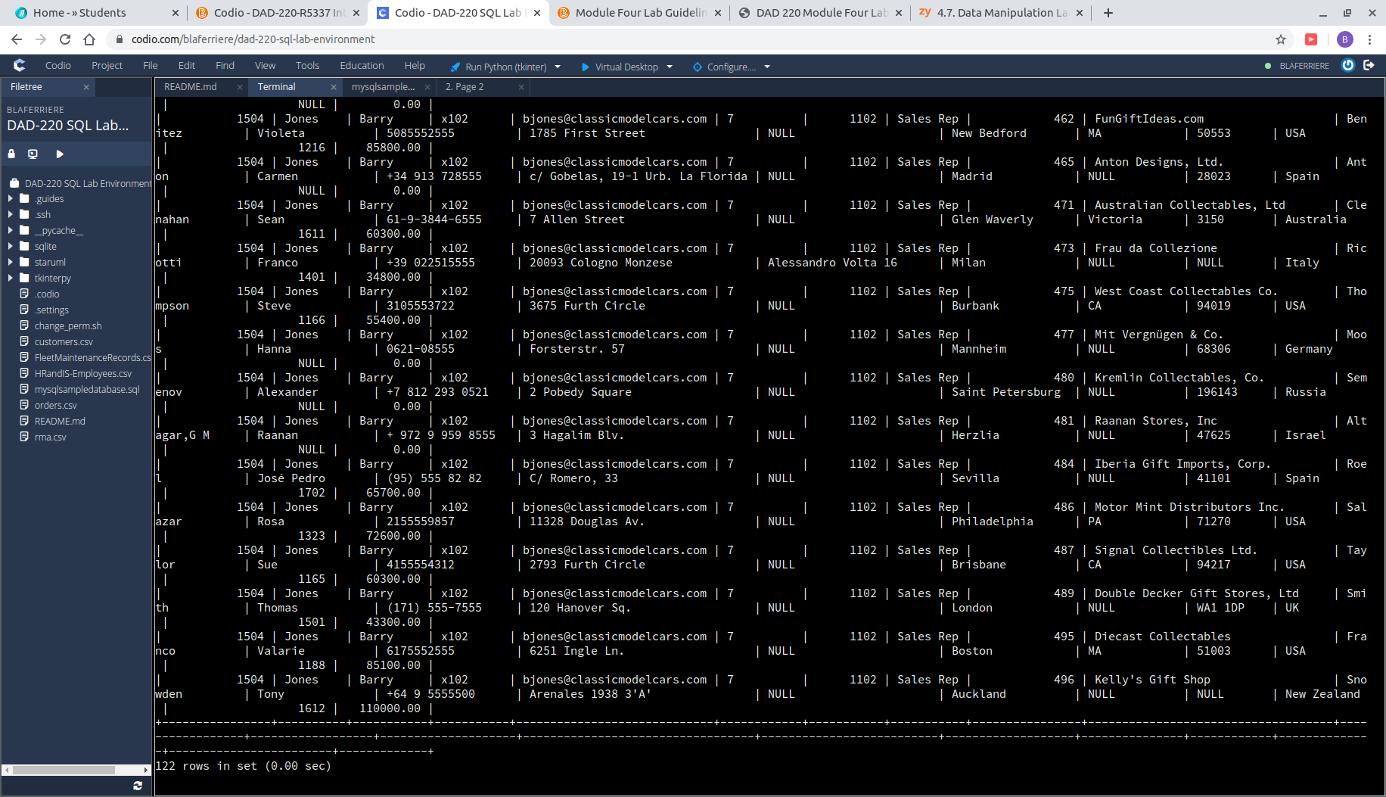

* 1. The relationship present is one-to-many. The employee Barry Jones has made many sales, to many different people, all on his own. The one would be on the employee side of the ER diagram and the M or many would be on the customers side.

1. **Retrieve records for customers who reside in Massachusetts** and **identify** their sales rep and if the relationships are one-to-one or one-to-many**.**

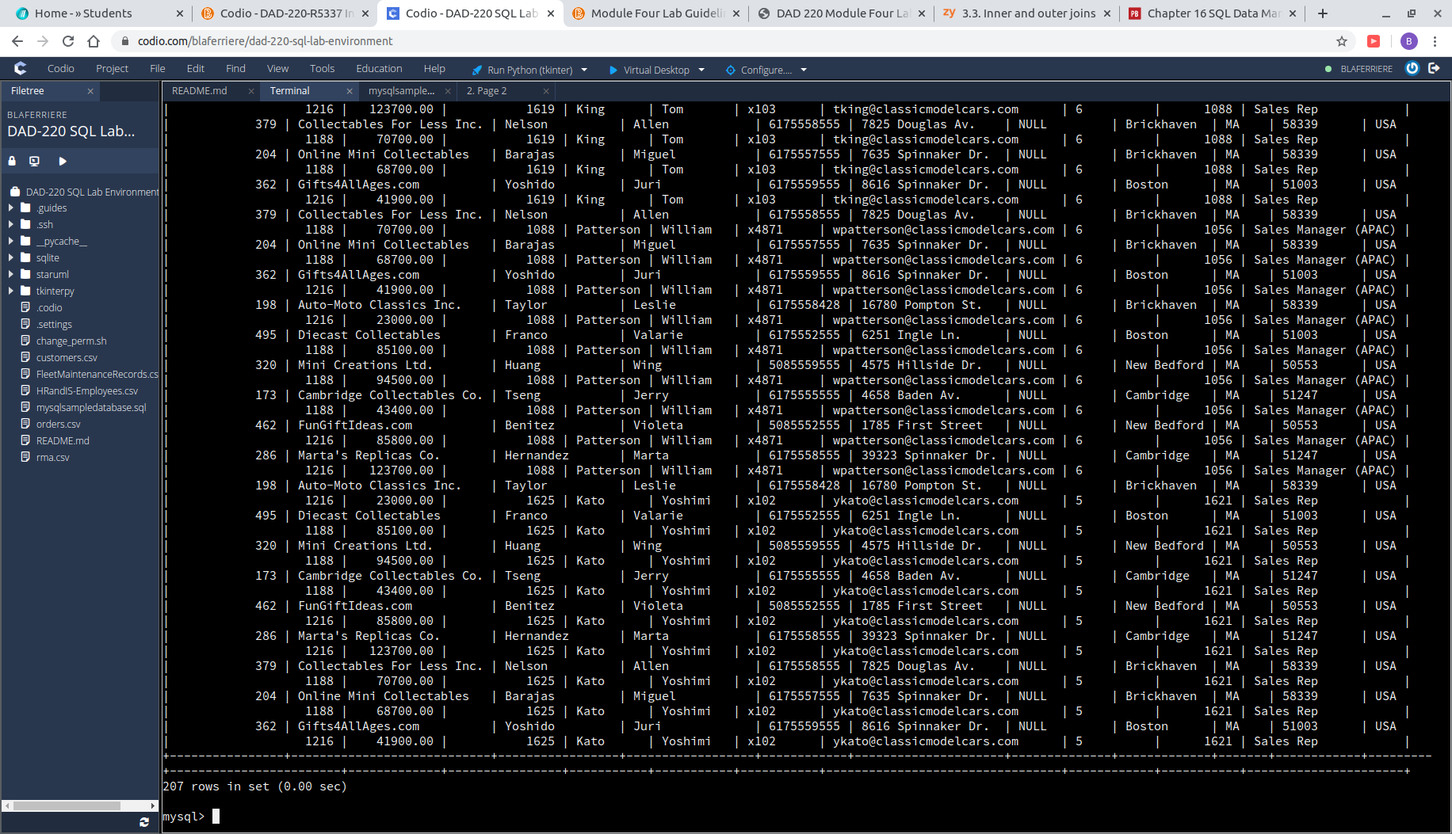

* 1. The customer to employee relationship is an example of one-many. Per one employee there are many customers, which can be see in the screenshot.

1. Add one customer record with your last name using an INSERT statement. You may use the name of a celebrity or fictional character if you don’t use your own name.

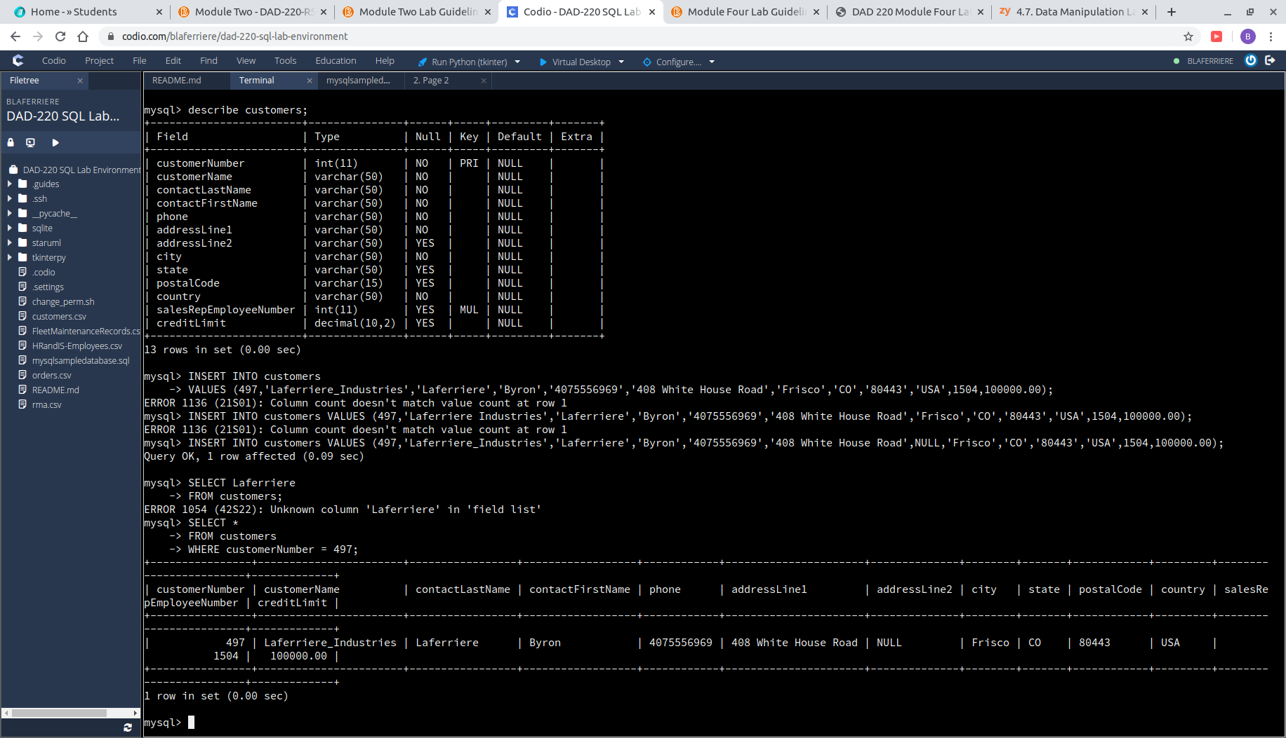

1. **Reflection**
   1. **Define how cardinality** is applied to the databases you’ve been working with and why different numbers of records returned from the different offices.
      1. Depending on the search being conducted, we see many different examples of cardinality. For example, searching to see what customers in ‘MA’ belonged to which employees, showed us how many customers can be attached to a single employee. However, when searching by orderNumber, we see that searches bring back one result instead. The specification of the search truly decides the results returned and the type of cardinality witnessed.
   2. **Compare and contrast** the different queries you ran and how cardinality applies to them.
      1. The different queries that were run through the machine highlight the different types of cardinality exemplified by the results. Running the INNER JOIN command, which connected the tables customers and employees, we saw a one-many attribute maxima in the results. Specifically searching by orderNumber brought back one-one results, showing the use of specificity in query. It can be useful to use both styles of query when searching depending on what information was being sought out. One benefit of specific searches is the narrowed results and the amount of time it takes to intake the information. A negative side to specific searches is that it could result in a less informed inquery. Cardinality plays an important in expressing relationships between entities and attributes and is imperative to keep in mind when querying databases.
   3. **Describe two of the crucial benefits of cardinality** in this type of database.
      1. Two of the major benefits of cardinality that are apparent in this activity are revealed in the complex relationships between tables. Cardinality helps define how each table is connected to each other while maintaining structure. The second crucial benefit of cardinality would be the query optimization that is offered when searching for multiple columns. Without cardinality, query execution would be much less effective.